Spine Phantom

Guidelines for Planning and Irradiating the Spine Phantom.
Revised December 11, 2025

GENERAL INFORMATION:
Each institution may keep the phantom for a period of time no more than 2 weeks. During this two-week period, the institution will image, plan, and treat the phantom and return. Thank you for your cooperation. Thank you for your cooperation with this constraint.
This phantom has been designed and constructed by the IROC. The IROC phantom contains two imaging and dosimetric inserts.

The insert, called spine, contains a PTV. There are two orthogonal sheets of radiochromic film passing through the center of the target and four TLD capsules within the target. The insert also contains normal structures: the spinal cord, bone and the esophagus. The insert which is part of the left lung contains a centrally located CTV. DO NOT treat this target. The phantom also contains normal structures: left and right lung and the heart with one TLD capsule in its center.

If you have any questions, please contact the appropriate person.

IROC Nadia Hernandez (713)-745-8989 Nhernand@mdanderson.org
IROC Andrea Molineu (713) 745-8989 amolineu@mdanderson.org

DOSIMETRY INFORMATION TO BE SUBMITTED:

The following information is to be submitted to the IROC (include in the phantom shipping box):

- Original hard-copy of the plan and isodose distributions applying correction for tissue heterogeneity in the sagittal and axial planes through the center of the target volume. Please ensure that each plane fills an entire page and that a scale is printed on the page.
- A completed IROC Spine Phantom Institution Information form.
- Please upload the Spine phantom digital data. The files to export to the IROC are the digital data for your Spine phantom irradiation in DICOM format, and include all CT slices, 3D composite dose file, structure file and plan file. A folder had been created with your institution name on OneDrive and it will be shared with you, upload the digital data there.

DOSE PRESCRIPTION:
1. USE tissue heterogeneity correction when planning and calculating M.U. for the phantom irradiation.
2. Only photon beams with nominal accelerating potential between 4 and 15 MV are allowed.
3. The plan designed for this phantom requires stereotactic localization and IMRT techniques or any other dose painting techniques. The uncertainty in localization should be less than 2 mm from simulation/planning to the end of treatment delivery.
4. Three-dimensional coplanar or non-coplanar beam arrangements using IMRT should be designed to deliver highly conformal prescription dose distributions. The beam arrangement should be mostly from the posterior direction to avoid passing the radiation beam through the lungs. Intensity-modulated arc therapy with either multiple static cones or dynamic conformal MLC can be used. For arc rotational techniques, every effort should be used to limit the radiation through the lung.

The prescribed dose to the phantom is 6 Gy to at least 90% of the PTV. The prescription dose will be delivered to the margin of the target volume It should be delivered in 1 fraction with the following constraints:
- PTV:
  - Prescribed dose of 6 Gy to at least 90% of the PTV.
  - The minimum dose to the target should be no less than 5.25 Gy.
  - Any dose greater than 105% of the prescription dose should not occur outside of the target volume.

- Critical Normal Structures (spinal cord, heart, esophagus, skin and lungs):

Constraints for all the normal structures are specified in the following table:

Normal structure | Volume | Volume Max (Gy) | Max Point Dose (Gy)
Spinal Cord | <0.35cc  <1.2cc | 3.75  2.63 | 5.25
Heart | <15cc | 6 | 8.25
Esophagus | <5cc | 4.46 | 6
Skin | <10cc | 8.63 | 9.75
Whole Lung  (Right & Left) | 1000cc | 2.78

It is important to follow the constraints applied to normal structure as listed above.

If your plan does not conform to the above prescription, you may not be credentialed and will have to irradiate the phantom again.

Please, DO NOT TREAT the CTV located in the left lung
IRRADIATING THE PHANTOM
- Material included in box:
The phantom should be imaged, planned and irradiated as if it were an actual protocol patient, incorporating all of your customary quality assurance checks.
Spine Phantom, with 3or 6 TLD capsules taped to the shell (1 or 2 on left side, 1 or 2 on right side and 1 or 2 on anterior side). Place TLDs on tin can labeled Background TLDs.
Insert for the left lung, already in phantom, please take out when filling with water.
Insert for the spine
Rubber hose
Acrylic cylinder containing TLD in one of the ends
Envelope with background film (hidden from your view; please don’t try to find it)
Mailing label to return case to IROC at the IROC’s expense.
Procedures:
- Fill the phantom with water:
  - Thread the rubber hose into the filler hole placed on the base of the phantom. Take lung insert out before filling with water.
  - Fill slowly with water (the rubber hose stretches over most faucets). There is a breathing hole on the phantom, make sure it is open, to allow the pressure to release. You may need to jiggle the phantom to release air trapped inside the cavity.
  - Remove hose and replace acrylic screw.
- Allow the phantom to sit with water in it for 20 min. to check for leaks.
- Look in the insert spaces (lung and spine) and check for water leakage. If you find any water call the IROC. If not, proceed to the next step.
- Position the spine insert. Remove the screws located on the left and right side of the insert place. Align the red mark. When it is in the correct position put the screw back.
- Position the lung insert. Align the red mark. Make sure that the insert is in its correct position by making small rotations of the insert around its central axis. When it is in the correct position it will be locked in place by an indentation at the end of the insert.
- Position the acrylic cylinder labeled “heart cylinder” in the hole labeled “heart” in the superior part of the phantom. The hole and the cylinder are marked in green. You will see a TLD capsule in the cavity closed with a screw. The end with the TLD should be inserted first.
- Position and CT the phantom as you would a patient including immobilization techniques. You may wish to scan with 1.5 mm slices especially near the target to better identify the TLD capsules. NOTE: There are TLD on the external shell of the phantom to give us an estimate of the CT dose to the target.
- Remove inserts from the phantom during planning process. Store inserts in a dry place. Store inserts and phantom where they will not be irradiate.
- Segment the phantom images contouring the skin, lungs, heart, spinal cord esophagus, bone and PTV. Also contour all the 5 TLD volumes. Please use the following names for these contours:
PTV_TLD_sup_ant for the superior anterior TLD in the
target,
PTV_TLD_inf_ant for the inferior anterior TLD in the
target,
PTV_TLD_sup_post for the superior posterior TLD in the
target,
PTV_TLD_inf_post for the inferior posterior TLD in the
target,
HEART_TLD for TLD in the heart
• The dimensions of the TLD volume are approximately 10 mm long by 2 mm diameter
• The outside dimensions of the TLD capsules are 15 mm long by 4 mm diameter; the TLD axis is normal to the axial plane. (The capsules and the TLD should be visible on CT image)
- Plan the treatment as specified in the DOSE PRESCRIPTION above.
- Look in the insert spaces and check for water leakage. If you find any water call the IROC. If not, follow the instructions in step 5 and 6 to position the inserts again and proceed to the next step.
- Perform your customary QA of the plan prior to irradiating the phantom.
- Irradiate the IROC TLD block according to the instructions provided.
- Position the phantom as you would a protocol patient including immobilization techniques.
- REMOVE THE TLD CAPSULES LOCATED ON THE EXTERNAL SHELL. Put them into the designated envelope.
- Irradiate the phantom with the developed plan.
- Remove the acrylic cylinder from hole and place it in the box.
- Remove the spine insert and place it in the box.
- Please verify that there is no water in the inserts space. If you find any water call the IROC.
- Remove the screw on the base of the phantom and drain the water from the phantom.
- Put the empty phantom in the box.
- Make sure that the envelope with the TLD on the shell and the rubber hose are in the box.
- Include the dosimetry data discussed above. Complete the attached forms.
- Return the complete package to the IROC.

IROC Spine Phantom Institution Information
Institution:
Address:

Treatment Unit used for irradiation:
Manufacturer: Model (Head model if Elekta):
Serial number: _______________________
Photon Energy Nom __________(MV)
Is this a: FFF beam ________ or SRS beam __________
Person performing irradiation:
Irradiation date: ________________

IMRT Technique for this irradiation:
___ Segmental (step and shoot) MLC ___ Dynamic MLC ___ Tomotherapy
___ VMAT Other: _______________________________

Intensity Modulation Device for this irradiation:
___ Multileaf Collimator Model: ___________________________________
___ Other: _____________________________________________________

TPS information for this irradiation
Manufacturer __________________ Model_____________ Algorithm_________________
Version number ________________

Contact Information for this irradiation
Physicist to receive report:
Person to call in case of questions:
Phone Number:______________________ Email address: _______________________________

Indicate the dose delivered to the TLD as determined by your treatment planning computer
TLD | Mean Dose (Gy)
PTV_TLD_sup ant
PTV_TLD_inf ant
PTV_TLD_sup post
PTV_TLD_inf post
HEART_TLD

Results of the QA:______________________________________________________________
Did you adjust the MU based on these results?_______________If so, how much?___________
Attach copies of the treatment plan including slices in the sagittal, axial and coronal film planes.

Comments: _________________________________________________________________________ ___________________________________________________________________________________
___________________________________________________________________________________

Please enclose original copies of your treatment plans. Include axial and sagittal planes through the target center. Include scaling factors for each plane. FTP the digital treatment planning data.

For Office Use Only | TLD Batch  20 | EBT4 LOT # 03042502 | Phantom ID # | Code | Date Sent |  | Date Rec'd

This is a cross sectional view of the phantom
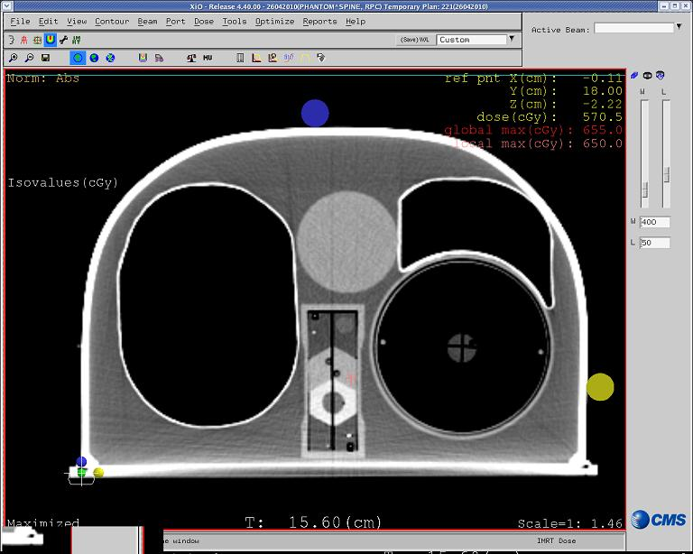
Esophagus

Sagittal Film Plane
Left
Lung
Right
Lung
Heart
PTV
Cord
Bone

Axial Film Plane
Posterior
Right
Left
Anterior

Note: Please ignore all markings on the external shell of the phantom, use your own system to position the phantom.

Note: You need to deliver 6.0 Gy to the PTV located on the Spine insert in 1 fraction.

Total dose to the PTV 6.0 Gy

DO NOT treat the target located inside the left lung

Thanks

Phantom team @ IROC HOUSTON!

